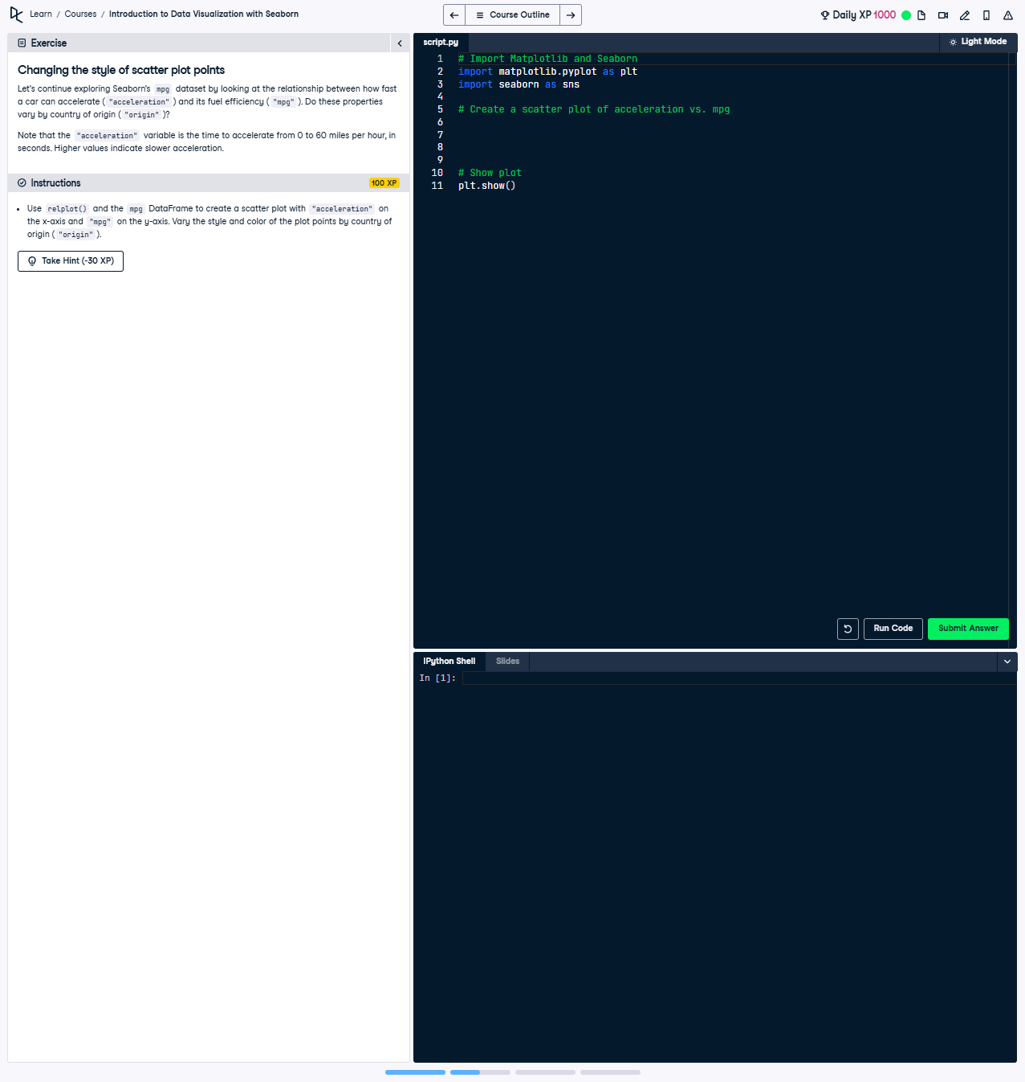

Changing the Style of Scatter Plot Points

Use relplot() and the mpg DataFrame to create a scatter plot with 'acceleration' on the x-axis and 'mpg' on the y-axis. Vary the style and color of the points by the country of origin ('origin').

### Full Answer ###

The following code creates a scatter plot using relplot(). It varies the style and color of the points based on the country of origin ('origin'). Below is the working code:

import seaborn as sns  
import matplotlib.pyplot as plt  
  
# Create scatter plot of acceleration vs. mpg with style and color based on origin  
sns.relplot(x='acceleration', y='mpg',  
 hue='origin',  
 style='origin',  
 data=mpg,  
 kind='scatter')  
  
# Show plot  
plt.show()

### Code Explanation ###

1. Import seaborn and matplotlib.pyplot for creating visualizations.  
2. Use sns.relplot() to create a scatter plot with:  
 - 'x' set to 'acceleration' for acceleration values.  
 - 'y' set to 'mpg' for fuel efficiency.  
 - 'hue' set to 'origin' to vary the color of the points by country of origin.  
 - 'style' set to 'origin' to vary the style of the points by country of origin.  
 - 'data' set to mpg, the DataFrame containing the data.  
 - 'kind' set to 'scatter' to generate scatter plots.  
3. Use plt.show() to render and display the plot.